The End of Continuous Observation
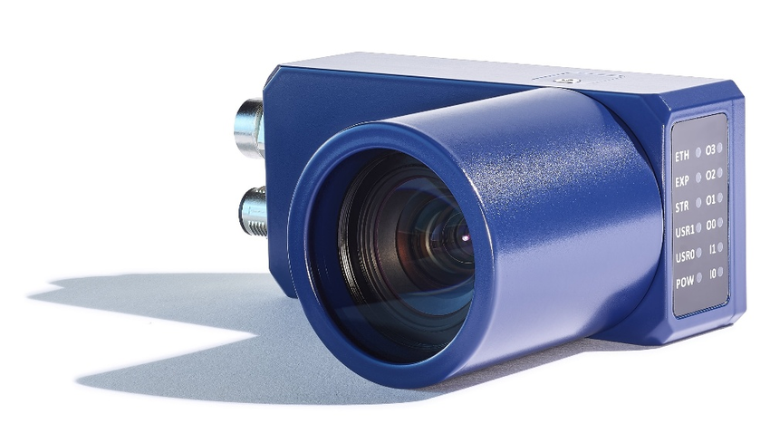
© Imago
The idea: data is only recorded from the time when a certain event occurs.

Event-Based Vision ist a completely new and cost-effective approach to monitoring fast-moving processes that is fundamentally different from conventional image processing concepts.
Counting objects, monitoring moving parts or controlling vibrations is possible with image processing, but there are technological limitations: The faster the processes to be monitored run, the higher the demands on the vision systems - and thus naturally also their price. Many innovative ideas, therefore, are set aside if their implementation requires a fast and therefore expensive image processing system and risk not to pay off. Other ideas are often not even tackled in the first place because the image processing algorithms are considered too complex and prone to error.
A practical example: To avoid expensive repairs and long downtimes, it is useful in certain cases to analyze the vibrations of machine parts and to detect in time if these components vibrate outside specified limits. A technical option for solving such tasks could be sensors that would have to be adapted to the components. However, this is a costly approach and may require a new design.
Such a task can also be solved theoretically with image processing systems. However, the main problem when using this technology is the selection of the frame rate: If an event occurs between the images, it is not registered and the desired information is not available. In this case, users could use increasingly faster and thus more expensive vision systems and still miss their target: Regardless of whether processes are observed at repetition rates of 100, 1 000, or 10 000 Hz, events between two images can remain undetected.
Events as a kick-off
An alternative solution is now available for similar tasks. The basic idea: Data is only recorded from the time when a certain event occurs. This mode of operation is called event-based. It describes a completely new concept for monitoring fast processes and is fundamentally different from typical camera sensors that deliver images at a certain repetition rate, which are then evaluated.
The basis of this technology is the event-based sensor 'Monet', which is developed and produced by the French company Prophesee. Already on the chip itself, an intelligence is implemented in every pixel, which allows to detect movements and to send an event independently, without a pre-set line or frame rate. Each pixel, therefore, decides for itself when it generates an event and sends data to the evaluation computer. The Monet chip works with frequencies of up to 30 000 000 Hz and is therefore also suitable for applications in which very fast movements must be detected.
Events instead of frames
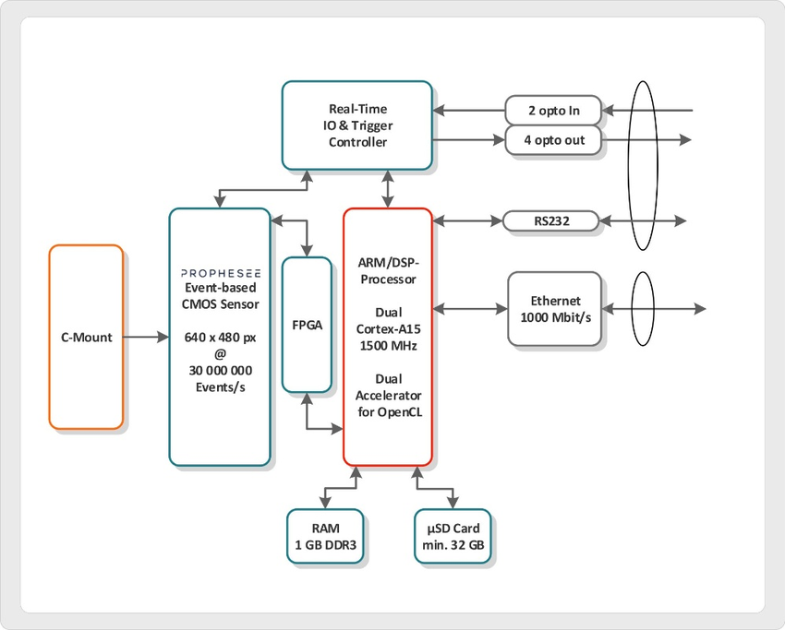
Block diagram of the Event-Based ‚VisionCam EB‘.
Based on this sensor, IMAGO Technologies has developed the camera system 'VisionCam EB' in the format of a typical smart camera. If an object moves in front of a 'VisionCam', more than 300 000 pixels are able to detect this event and generate events. The event-based chip is directly connected to the dual-core processor with ARM architecture and Linux operating system integrated into the 'VisionCam EB'. In contrast to conventional image processing systems, this architecture does not store image after image in a memory and then evaluate it using suitable image processing algorithms. Instead, events are continuously stored in the main memory, which are provided with coordinates and a time stamp.
Compared to image processing, event-based vision is no longer referred to as 'images' but as two-dimensional signal processing. The art of mathematics is to interpret the stored events. To make mathematics easier for a number of applications, Prophesee provides a library. This library can already be used directly for applications such as vibration analysis. However, the developer must develop an application-dependent program for the Linux OS including a web GUI. Furthermore, the developer is free to invent and integrate his own algorithms.
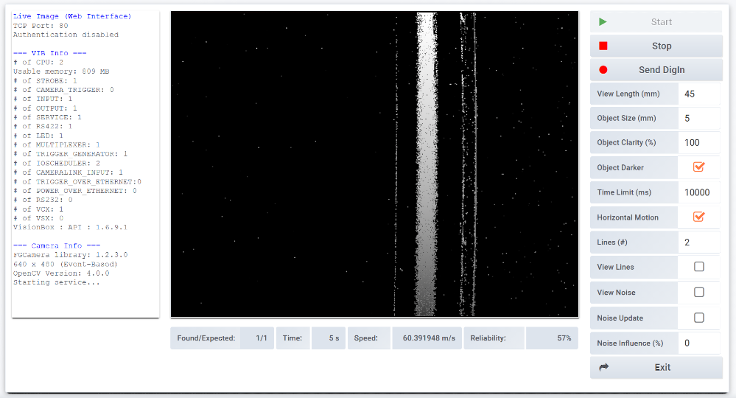
Parts that fly through the detection range of a 2D event-based sensor trigger many events that can easily be statistically evaluated.
A further application example illustrates the functionality of event-based vision: A NG part is 'shot' out of a machine by compressed air and is to be detected in a dusty environment. This task is not easy to solve for conventional image processing systems, but it is no problem for the 'VisionCam EB': The ejected part flies through the detection range of the 2D event-based sensor and triggers many events, which can be statistically evaluated much more easily than the few detectable pixels of a high-speed camera. The system is also very robust.
Simplified lighting and optics
Event-based systems also have clear advantages in terms of the lighting and optics used. In classic image processing systems, LED lighting is often flashed to create the necessary brightness for the shot. Strobe controllers are used to synchronize with the image sensor, which results in higher costs and more effort when setting up an application. In an event-based application, however, flashed lights would trigger events, so strobe controllers are not required. The simplest LED headlights, which provide constant bright lighting, are quite sufficient. The question of the optimum optics is also answered very quickly with event-based systems: standard lenses with C-mount connection meet all requirements.
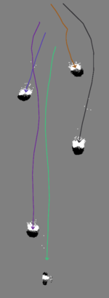
Event-based approaches enable simplified tracking of particles.
The development environment itself consists of a Microsoft Visual Studio editor, which is connected to the 'VisionCam EB' via a plug-in and compiles the code there. Similar to conventional image processing systems, the 'VisionCam EB' provides debugging information to the application developer. The SDK of the camera operates the necessary interfaces such as event grabbing, 1 Gbit/s Ethernet, digital I/Os, or a serial interface. Sample programs of the simplest kind show, among other things, how events can be evaluated with statistics.
Higher-quality algorithms are available in the so-called Metavision Library from the sensor manufacturer Prophesee. Further support is also at hand for the development of a web-based GUI. Due to the effort required for completely new application development, the 'VisionCam EB' is more suitable for series production than for individual projects.

The VisionCam family is also available with classical sensors: The ‘VisionCam XM’ offers a resolution of up to 5.3 MPixel, which covers a wide range of applications. With the intelligent line scan camera 'VisionCam LM' up to 8k resolution is possible. So, IMAGO offers a wide range of Linux-based, freely programmable smart cameras, which have sufficient computing power onboard for many applications and can be used without an extra computer for processing. This product family is complemented by a little brother, the 'VisionSensor'. This device is based on an ARM CPU and a WVGA sensor is within the price range of a typical sensor and allows the individual design of complete image processing applications.

IMAGO will shortly be presenting the 'VisionSensor' in an event-based version. Target customers for these products are machine vision engineers who understand their specific application, develop optimized solutions, require the source code for any extensions, and, in the case of line scan and area scan cameras, optionally use MVTec's 'Halcon' library.

About IMAGO Technologies
IMAGO Technologies is a leading manufacturer of intelligent cameras, vision sensors and special computers for automated image processing. IMAGO designs, develops, manufactures and distributes image processing systems in Friedberg, Germany, for customers worldwide in industrial inspection, pharmaceutical-, engineering industry, and ... soon also for your application? For almost 3 decades, IMAGO has been offering trendsetting solutions with great innovative power serving the individual needs of customers.
The product portfolio includes intelligent line, area and event-based cameras, deep learning image processing computers as well as embedded multicore ARM, i-Core and DSP computers, each with real-time IO, Linux or Windows operating systems and a real-time OS. IMAGO also supports its customers in the areas of engineering and software development.

For more information, visit www.imago-technologies.com

